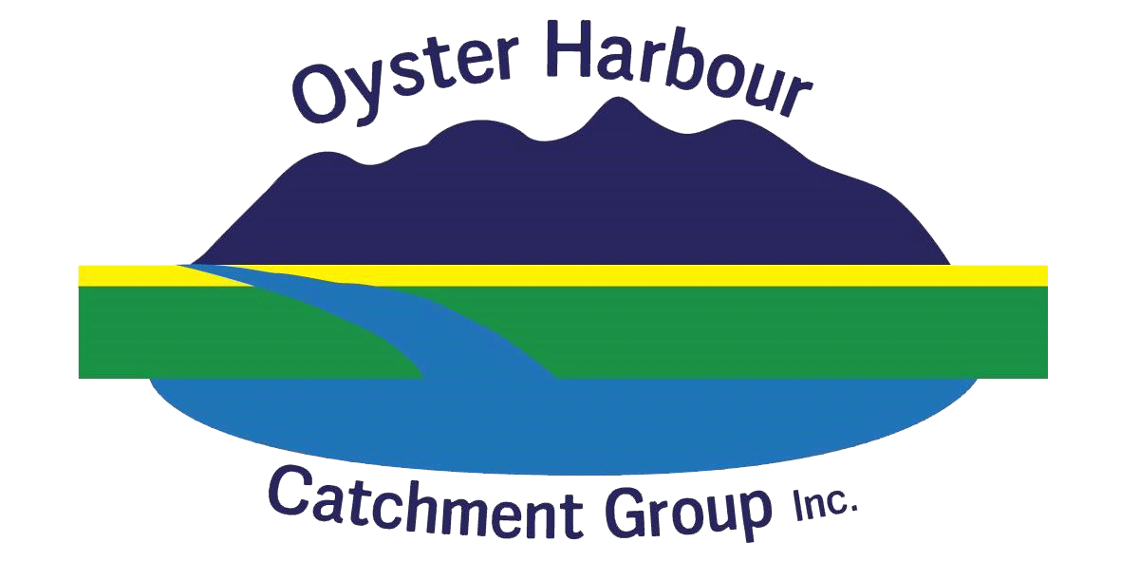
Oyster Harbour Catchment Group Inc
EXPRESSION OF INTEREST FORM

The Oyster Harbour Catchment Group is the natural resource management (NRM) non-profit, community group that cares for the King and Kalgan rivers which drain into Albany. We aim to improve the health of the catchment and productivity across the catchment through sustainable landuse practices.

To assist in developing and implementing projects across the catchment, we are calling on all landholders and residents to let us know what you need. We want to help you achieve your own NRM, Landcare and sustainability goals. Your information will help us allocate existing funding and/ or build projects.
Please complete this Expression of Interest and return it to OHCG Office/ team member. Your privacy will be secured according to OHCG rules found online at: www.ohcg.org.au
Please return this form to the Oyster Harbour Catchment Group Inc.
PO BOX 118, Mt Barker WA 6324 or email: communications@ohcg.org.au
Name:
Phone:
Email:
Location #/ Address:
District ie.Napier

What on-ground works are you looking for support with:
On-ground works | Please tick | Indicate approximate area/ length
Waterway fencing
Waterway revegetation
Remnant vegetation fencing
Revegetation to link/ buffer remnant vegetation
Flora and Fauna surveys
Weed control
Feral animal control
Stock crossings and watering points

Please indicate if the following is of interest to you:
 | Borrowing fox and/ or cat traps
 | Becoming a member of the Oyster Harbour Catchment Group (OHCG)
 | Becoming an OHCG committee member
 | Volunteering at the OHCG
Attending information and workshop sessions on:
 |  | Weeds |  | Native flora and fauna surveys
 |  | Revegetation/ Planting Natives |  | Managing erosion risk
 |  | Waterway testing and monitoring |  | Soil health and testing
 |  | Feral animal control |  | Remnant vegetation protection and rehabilitation
 |  | Waterway protection and rehabilitation |  | History, culture and connecting with the environment
 |  | Farm planning/management |  | Catchment planning
All the above
Other:

