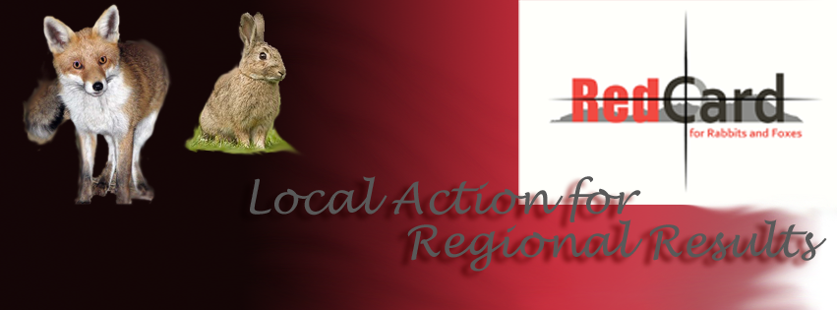-------------------------------------------
Red Card Feral Animal Shoot 2024
Red Card Feral Animal Shoot in the Oyster Harbour Catchment and surrounding area
Manypeaks Shoot– 6 pm Friday the 12th of April to 6 am Saturday the 13th April 2024
Follow up Tally and cooked breakfast presented by Oyster Harbour Catchment Group and Delta Ag breakfast signage will be displayed just north of Manypeaks town site at Howies Farm at 7 am 13th of April

Facilitated by Oyster Harbour Catchment Group, Supported by Red Card for Rabbits and Foxes and Sponsored by Sporting Shooters Association of Australia WA (SSAA)

1. Liability
All responsibility rests with the participants, the shoot is a community activity that Oyster Harbour Catchment Group is coordinating. We are not formally associated with the running of this event. Oyster Harbour Catchment Group is organising the body count and the farmers are organising the shooting.
Responsibility of participants-

- Alcohol, shooting &driving don’t mix! Anyone found to be drinking during the shoot time slots will be disqualified
- Shooting only takes place on private land, with landowner’s consent, (property liability covers any incidents).
- Permission must be obtained to shoot on any property.
- Must inform neighbours of intention to shoot.
- Do not shoot towards property or roads
- Guns are to be left at home (or locked in vehicle) at the tally up.
- By law all guns must be licensed, and shooters must have safety accreditation.
- Road and farm legalities must be adhered with any vehicle use.
- The Sporting Shooter’s Association of Australia (WA) have insurance for their members. We encourage participants to become SSAA members information available www.ssaawa.org.au
- RSPCA support the culling of declared feral species as long as it’s done in a humane way, with as little stress possible inflicted on the animal (shoot to kill from stationary position using a proper calibre rifle)
- Important- Due care and consideration must be taken when targeting feral cats.
- Cats MUST NOT be wearing a collar.
- MUST NOT be close to a dwelling.
- Property, where shooting is to take place, must be advised to keep cat’s indoors.

To register
- Please provide a list detailing participants in your team, including yourself
- Please provide a tally of feral animals culled during the shoot to the Program Coordinator and provide photo evidence of the results if required. (Phone pictures accepted)
Any verified complaints may end in disqualification, not following these recommendations may end in disqualification
The following safety code must be adhered to

THE NATIONAL FIREARMS SAFETY CODE
1. Treat every firearm as if it is loaded.
2. Your firearm is your responsibility.
3. Always ensure your firing zone is clear and identify your target beyond
all doubt.
4. Never point a firearm at or near another person.
5. Never load a firearm until you are ready to shoot.
6. Keep your finger off the trigger until you are ready to shoot.
7. When you have finished shooting remove the magazine (if fitted), unload and then check that the chamber is empty.
8. Make sure that all firearms are transported securely to prevent misuse or theft.
9. Never allow unauthorised access to your firearm(s) or ammunition.
10. Do not climb fences or obstacles with loaded firearms.
11. Encourage safe and responsible handling of firearms in the field, on the range, and within the community.
12. Never mix shooting with alcohol or drugs.
13. Understand the operation of your firearm, keep it in good repair, and always use the correct ammunition.
14. Never store firearms and ammunition together. Ensure they are safely locked away when not in use.
15. Be familiar with the legal requirements for safe storage, firearms ownership, possession and use in your state or territory, or in the state or territory you are visiting.
16. Dispose of unwanted firearms lawfully. Surrender them to the police or sell them to or through a licensed dealer.

2. Animal Welfare
The culling of declared pest species (such as foxes, rabbits, and feral cats) is not condoned by RSPCA. However, if the culling is done as quickly and humanely as possible, the RSPCA respects that this is an option for protecting overall biodiversity quality. The RSPCA stipulates that minimal stress is caused to the animal. Called the “shoot to kill” approach, it requires shooters to make only headshots from a stationary position using adequate calibre guns.
Animal welfare experts agree that shooting can be a humane method of killing animals when the following requirements are met:
- It is carried out by experienced, skilled, and responsible shooters.
- The animal can be clearly seen and is within range to achieve an instantly fatal shot.
- The correct firearm, ammunition and shot placement is used.
- Target animals are not chased (but stalked as not to alarm the animal) prior to shooting.
- Wounded animals are located and killed as quickly and humanely as possible.
- Death of the target animal is confirmed before shooting another animal.
3. Team information
- Teams of up to 6 are acceptable but must be able to safely and legally fit on the chosen vehicle.
- Each team takes full responsibility during the shooting, which is done on their own properties or pre-arranged property with consent and at their own risk. All guns are to be left at home or kept in a locked gun safe in a vehicle before teams come in for the tally breakfast.
- Bring whole bodies or tails
- Points will be awarded as follows
- Foxes – 5 points, Feral cats- 10 points, Rabbits- 2 points, Deer- 10 points, Pigs- 10 points, Goats- 10 points.
- Teams must dispose of carcasses responsibly on private land.

All participants in the shoot will understand and accept that full responsibility for safe and humane shooting practices lies with themselves and that "Red Card for Rabbits and Foxes" and local coordinators are not liable for any damage/injury caused as a result of this event.

Fox and rabbit control information

Fox and rabbit control is effective in Autumn because:
- Not much feed around – increases the chance of pests eating baits.
- Foxes are highly mobile.
- Young foxes are seeking new territory and aren’t streetwise.
- Feral animal shoot and control
- Fox shoots complement a baiting programme well, and often target different fox population. They can be held as a promotional activity in the lead-up to the baiting, or as a mop-up exercise after baiting has taken place.

AN INTEGRATED CONTROL PROGRAMME
Due to the high mobility of foxes (travel up to 15km/night), an effective programme requires maximum participation and approaching control from as many angles as possible. The “Red Card for Rabbits & Foxes” programme has grown since 2004 to encourage landholders across the broader landscape to control foxes and rabbits at the same time to have maximum impact. A big focus of the programme is to link with existing programmes to further increase the reach of fox and rabbit control. Major coordination stakeholders include Landcare groups, DPIRD and DBCA – and the major aim is to define a baiting period in Autumn to focus fox control activity – taking into account key community events (e.g., major field days, school holidays).
Each local area supports their local land managers (mainly farmers) to be involved in both shoots and 1080 baiting.
It is up to local organisers when they hold the fox shoot. Do consider the SSAA WA sponsored fox shoots from January – April, (see the website for dates) where $5 from each cat / fox shot will be donated by SSAA WA to The Regional Men’s Health Initiative (to a capped amount of $20,000)! A benefit in holding a fox shoot early then follow up with 1080 baiting is that young foxes are easier to shoot, and the older, sly foxes will be over the hill before a spotlight ever finds them. They will however eat a bait when they are hungry!

1080 BAITING
We encourage all farmers to lay baits on their own properties within the designated 8-week ‘hot period, which is 1st February – 30th April. For best results baiting should be done all year round but this period during and after the Red Card shoots can have a big impact on numbers. 1080 is classified as a S7 poison. It is fatally poisonous to non-native animals, including humans. Permits and training are required for its use – this is managed by the Department of Primary Industries and Regional Development.

KEY INFORMATION POINTS
- Department of Primary Industries and Regional Development training to accredit landholders for safe use of 1080 is compulsory (20 multi-choice questions and a quick chat about main points). The info booklet is available online or from the Department of Primary Industries and Regional Development https://www.agric.wa.gov.au/sites/gateway/files/Landholder%20information%20for%20the%20safe%20use%20and%20management%20of%201080%20PDF.pdf

