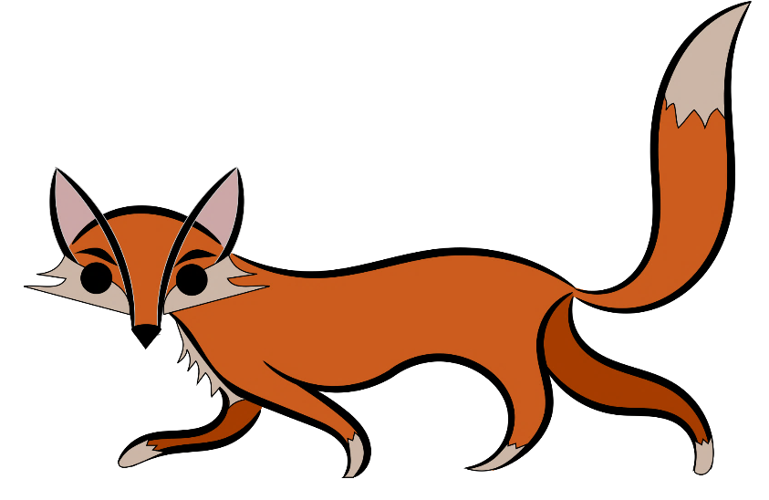
Red Card Feral Animal Shoot
2020

Saturday March 28th 6pm – Sunday March 29th 6am
Team Registration
Red Card Feral Animal Shoot facilitated by Oyster Harbour Catchment Group
Team Name
Team Contact Person
Contact Phone Number
Contact email
Property/’s where shooting will occur
Date of shoot
Team Members
Name of other members
1
2
3
4
5
Please leave firearms at home or securely locked in your vehicle during the Tally.
I have:
- accepted Oyster Harbour Catchment Group are not liable for any damage or injury caused as a result of this event
- accepted Oyster Harbour Catchment Group are not liable for any damage or injury caused as a result of this event
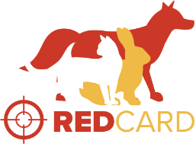
- agreed to the abide by the terms and conditions
- permission from the landholder
- notified neighbours

