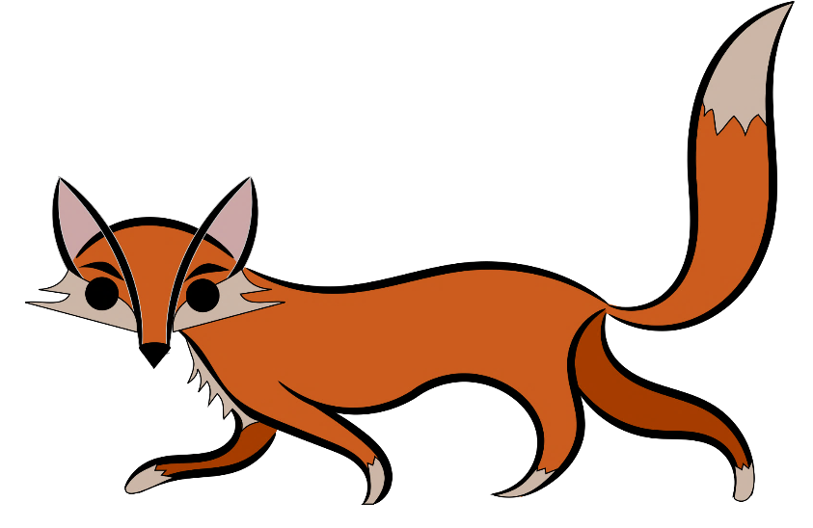
Red Card Feral Animal Shoot
2019

April 27th 6pm - April 28th 6am
Team Personal Tally - just for those that want a little more competition
Red Card Feral Animal Shoot facilitated by Oyster Harbour Catchment Group
Team Name
Contact Phone Number and email
Team Members | Feral Animal
Name of shooter | Foxes | Feral cats | Rabbits | Deer | Pigs | Goats
1
2
3
4
5
6
Total
All shooting must take place on private property with the consent of the property owner/s using licensed firearms. Alcohol and drug use is prohibited.
All participants in the shoot must accept that full responsibility for safe and humane shooting practices lies with themselves and that "Red Card for Rabbits and Foxes" and local coordinators are not liable for any damage or injury caused as a result of this event.
Please leave firearms at home or securely locked in your vehicle during the Tally.

